SOFTWARE REQUIREMENT SPECIFICATION

HOSPITAL MANAGEMENT SYSTEM

PUROPOSE OF THE SYSTEM:

The Hospital management system is an application that can be used to automate the workflow of recording the details of the inpatients and outpatients, Registrations, patient feedback. There are features like the email notifications, cancellation of the appointment etc.

PROBLEMS IN THE EXISTING SYSTEM:

* The current system is a manual one where in the hospital maintains all the information in the form of records. There by collecting necessary information with require a manual search in the record(s).
* Searching of the appointment can take much time to search whether the patient is booked for the appointment in manual system.
* Needed to maintain many record books for the in patients, outpatients, appointment details etc.

SOLUTIONS OF THESE PROBLEMS:

* The information of the entire firm will be maintained at a centralized data base any changes made by the other departs are known to the higher or lower departments instantly.
* Provide Interactive interface through which a user can interact with different areas of application easily
* Deploy the application on a single system and make is available on all the systems within the network, thereby reducing the maintenance cost of software.

SCOPE OF THE PROJECT:

Hospital Management-Patient System helps to maintain total patients in the Hospital. Patient records management system is a comprehensive patient care related clinical information system meant for doctors to enable quick review of previous medical history of patients and provide better quality treatment to the patients.

FUNCTIONAL COMPONENTS OF THE PROJECT:

Following is a list of functionalities of the system:

1. A person should be able to
   1. Login to the system through the first page of the application\
   2. Change the password after logging into the system
   3. See his/her appointment details.
   4. Query the bill of the patient.
   5. See his/her history of the appointment.
   6. See the patient’s prescription given by the doctor.
   7. Cancel his/her appointment booked with the doctor.

2. As soon as a cancellation request is made by the person, an automatic email should be sent to the person and his superior giving details about the action

3. The number of days of appointment should automatically be created to everybody and a notification regarding the same be sent to them automatically.

4. A summary report or the patient details should be sent to his mail i.e., the prescription details, total bill etc.

STUDY OF THE SYSTEM:

In the flexibility of the uses the interface has been developed a graphics concept in mind, associated through a browser interface. The GUI’S at the top level have been categorized as

1. Administrative user interface

2. The operational or generic user interface

The administrative user interface concentrates on the consistent information that is practically, part of the organizational activities and which needs proper authentication for the data collection. The interfaces help the administrations with all the transactional states like Data insertion, Data deletion and Date updation along with the extensive data search capabilities.

The operational or generic user interface helps the users upon the system in

Transactions through the existing data and required services. The operational user interface also helps the ordinary users in managing their own information helps the ordinary users in managing their own information in a customized manner as per the assisted flexibilities.

NO OF MODULES:

The system after careful analysis has been identified to be presented with the following modules:

* Registration Module.
* Out Patient Scheduling Module
* In Patient Monitoring Module.
* Patient Feedback.
* Admin Module.

Module I: Registration module consists of sub modules namely:

* + Maintains New Patient Registration.
  + Advance Payments, Appointment Facility from Doctors, Admission, Discharge (or) Transfer Details.

Module II: Outpatient scheduling module consists of sub modules namely:

• Maintains Daycare patient schedule and Referral patient schedule.

Module III: In-patient monitoring module consists of sub modules namely:

* + Maintains Casualty patient schedule, patient health status.

Module IV: Patient Feedback module consists of sub modules namely:

* + Maintains feedback from the patient.

Module V: Admin module consists of sub modules namely:

* + Provide access rights.

INPUTS/ OUTPUTS:

The main inputs, outputs and major functions of the system are as follows

INPUTS:

* + Admin enters his or her user id and password.
  + Patient enters his or her user id and password.
  + Patient send request for appointment.
  + Patient can check for status of appointment.
  + Admin can edit the patient details and so on...

OUTPUTS:

* Admin gets his homepage.
* Patient gets his homepage.
* Patient appointment request date will be stored in the database.
* Displays appointment status.
* Admin get patient details.

PERFORMANCE REQUIRMENTS:

Performance is measured in terms of the output provided by the application. Requirement specification plays an important part in the analysis of a system. Only when the requirement specifications are properly given, it is possible to design a system, which will fit into required environment. It rests largely in the part of the users of the existing system to give the requirement specifications because they are the people who finally use the system. This is because the requirements have to be known during the initial stages so that the system can be designed according to those requirements. It is very difficult to change the system once it has been designed and on the other hand designing a system, which does not cater to the requirements of the user, is of no use.

The requirement specification for any system can be broadly stated as given below:

* The system should be able to interface with the existing system
* The system should be accurate
* The system should be better than the existing system
* The existing system is completely dependent on the user to perform all the duties.

FEASIBILITY REPORT:

Preliminary investigation examine project feasibility, the likelihood the system will

Be useful to the organization. The main objective of the feasibility study is to test the Technical, Operational and Economical feasibility for adding new modules and debugging old running system. All system is feasible if they are unlimited resources and infinite time.

There are aspects in the feasibility study portion of the preliminary investigation:

* Technical Feasibility
* Operation Feasibility
* Economical Feasibility

Technical Feasibility

The technical issue usually rose during the feasibility stage of the investigation

Includes the following:

* Does the necessary technology exist to do what is suggested?
* Do the proposed equipments have the technical capacity to hold the data required to use the new system?
* Will the proposed system provide adequate response to inquiries, regardless of the number or location of users?
* Can the system be upgraded if developed?
* Are there technical guarantees of accuracy, reliability, ease of access and data security?

Earlier no system existed to cater to the needs of ‘Secure Infrastructure Implementation System’. The current system developed is technically feasible. It is a web based user interface. Thus it provides an easy access to the users. The database’s purpose is to create, establish and maintain a workflow among various entities in order to facilitate all concerned users in their various capacities or roles. Permission to the users would be granted based on the roles specified. Therefore, it provides the technical guarantee of accuracy, reliability and security. The software and hard requirements for the development of this project are not many and are available as free as open source. The work for the project is done with the current equipment and existing software technology. Necessary bandwidth exists for providing a fast feedback to the users irrespective of the number of users using the system.

Operational Feasibility

Proposed projects are beneficial only if they can be turned out into information system. That will meet the organization’s operating requirements. Operational feasibility aspects of the project are to be taken as an important part of the project implementation. Some of the important issues raised are to test the operational feasibility of a project includes the following: -

* Is there sufficient support for the management from the users?
* Will the system be used and work properly if it is being developed and implemented?
* Will there be any resistance from the user that will undermine the possible application benefits?

This system is targeted to be in accordance with the above-mentioned issues.

Beforehand, the management issues and user requirements have been taken into

Consideration. So there is no question of resistance from the users that can undermine the possible application benefits.

The well-planned design would ensure the optimal utilization of the computer resources and would help in the improvement of performance status.

Economic Feasibility

A system can be developed technically and that will be used if installed must still be a good investment for the organization. In the economical feasibility, the development cost in creating the system is evaluated against the ultimate benefit derived from the new systems. Financial benefits must equal or exceed the costs. The system is economically feasible. It does not require any addition hardware or software. Since the interface for this system is developed using the existing resources and technologies available. There is nominal expenditure and economical feasibility for certain.

ER DIAGRAMS

* The relation upon the system is structure through a conceptual ER-Diagram, which not only specifics the existential entities but also the standard relations through which the system exists and the cardinalities that are necessary for the system state to continue.
* The entity Relationship Diagram (ERD) depicts the relationship between the data objects. The ERD is the notation that is used to conduct the date modeling activity the attributes of each data object noted is the ERD can be described resign a data object descriptions.

* The set of primary components that are identified by the ERD are
  + Data object
  + Relationships
  + Attributes
  + Various types of indicators.

The primary purpose of the ERD is to represent data objects and their relationships.

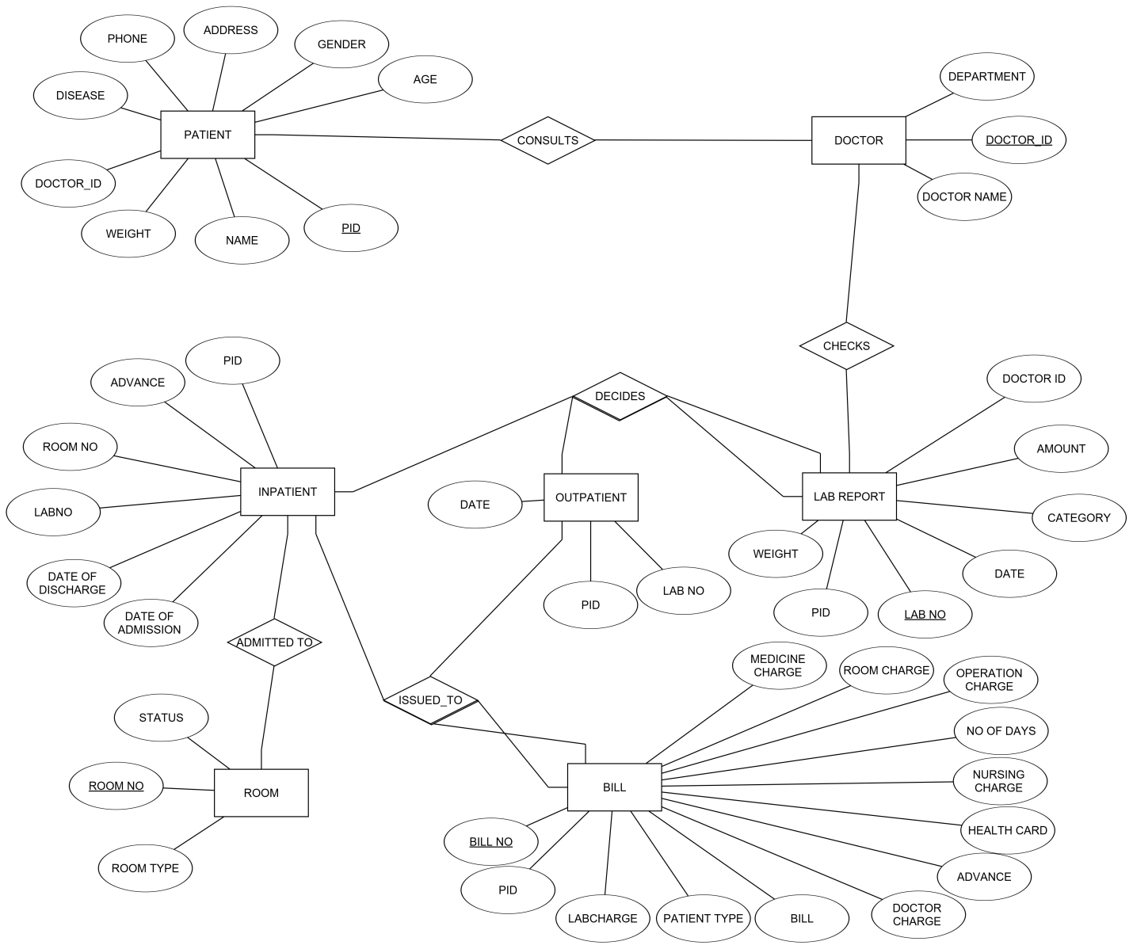

**DATA FLOW DIAGRAMS**

Zeroth level DFD diagram:

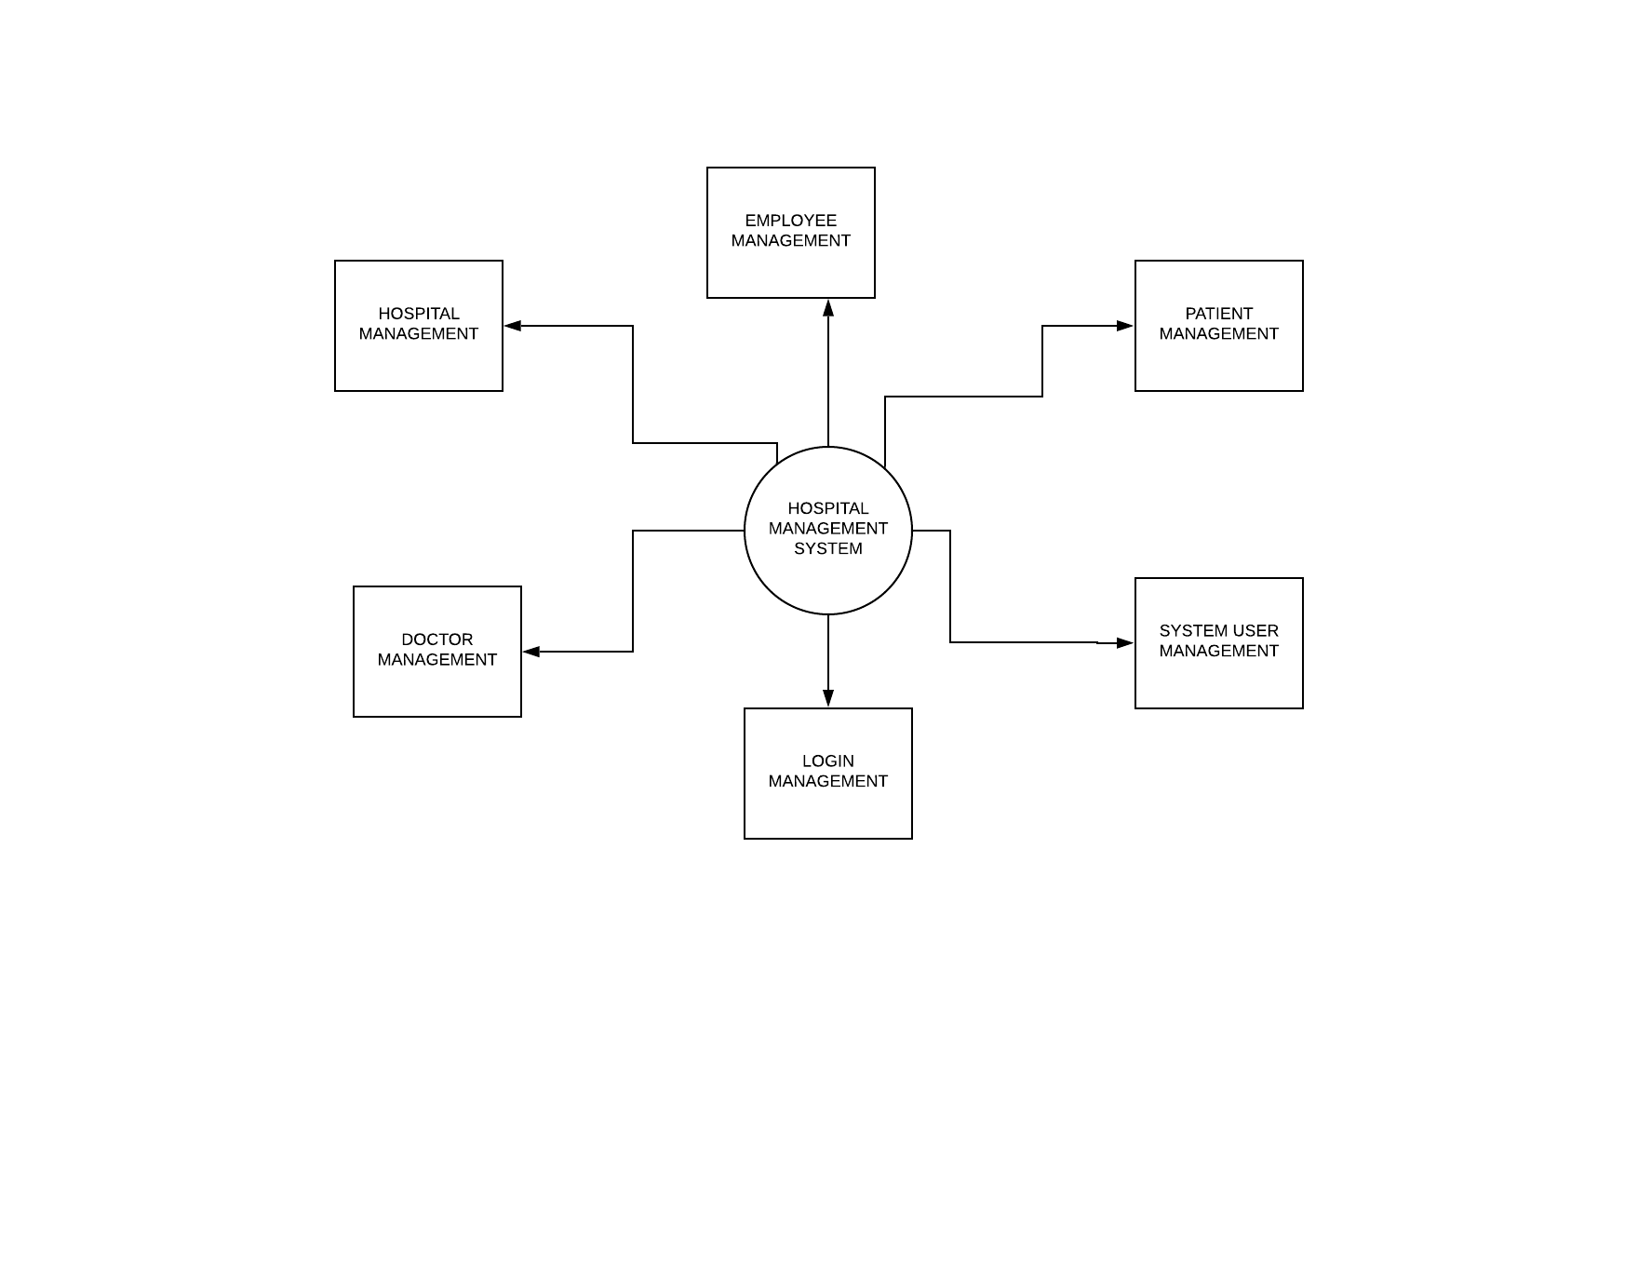

First level DFD diagram:

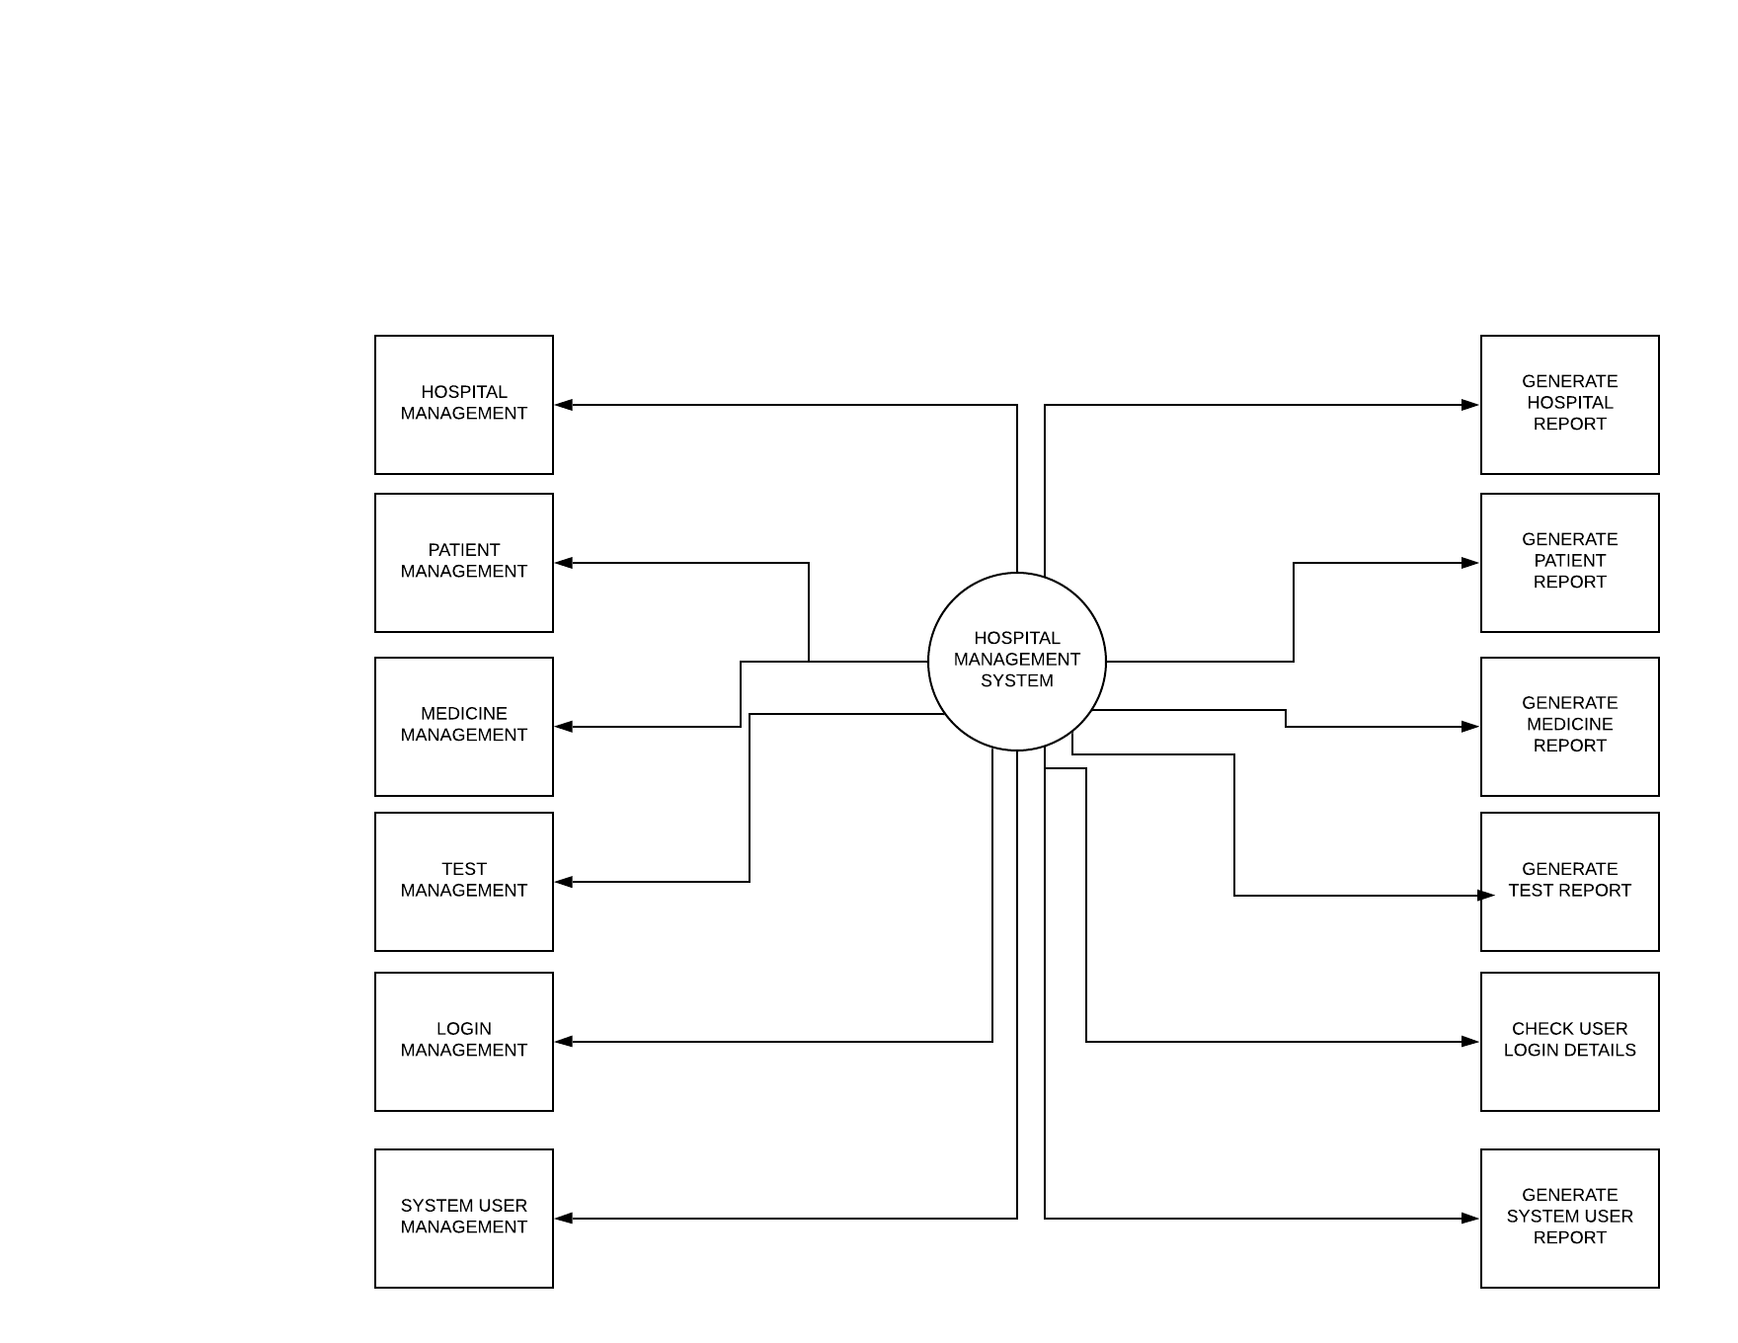

Second level DFD diagram:

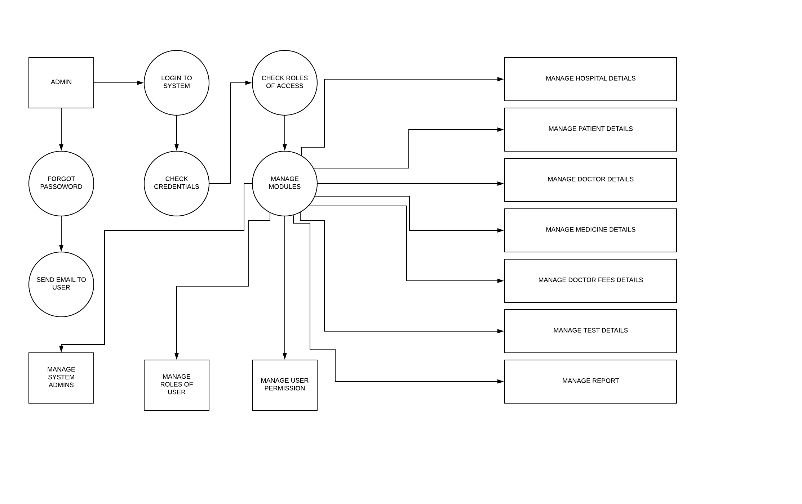

Third level DFD diagram:

